Diameter of a Solid Cylinder
# Source: AI Source: Provided by: [Data Path: Persons Table -> ID Column: 1, Name_En Column: Motasem Essam] -> From: [ChatGPT] on [7/25/2026]
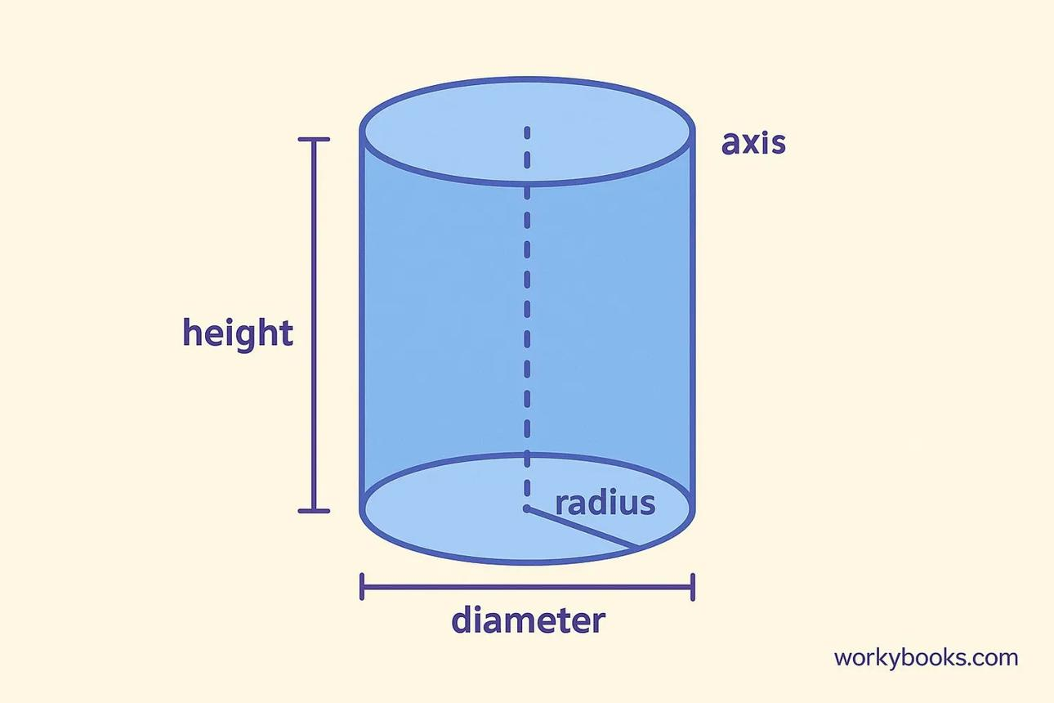

Definition
# Source: AI Source: Provided by: [Data Path: Persons Table -> ID Column: 1, Name_En Column: Motasem Essam] -> From: [ChatGPT] on [7/25/2026]
The diameter of a solid cylinder is the length of a straight line segment that passes through the center of a circular base and connects two opposite points on its circumference.
Unlike a hollow cylinder, a solid cylinder has no internal opening. Its diameter measures the full width of its circular base, from one external edge to the opposite external edge through the center.
The diameter is commonly represented by $D$ or $d$.
$$\boxed{D=2r}$$
where \(r\) is the radius of the circular base.

Simple Definition
# Source: AI Source: Provided by: [Data Path: Persons Table -> ID Column: 1, Name_En Column: Motasem Essam] -> From: [ChatGPT] on [7/25/2026]
The diameter of a solid cylinder is the distance across its circular base through the center.

Geometric Representation
# Source: AI Source: Provided by: [Data Path: Persons Table -> ID Column: 1, Name_En Column: Motasem Essam] -> From: [ChatGPT] on [7/25/2026]
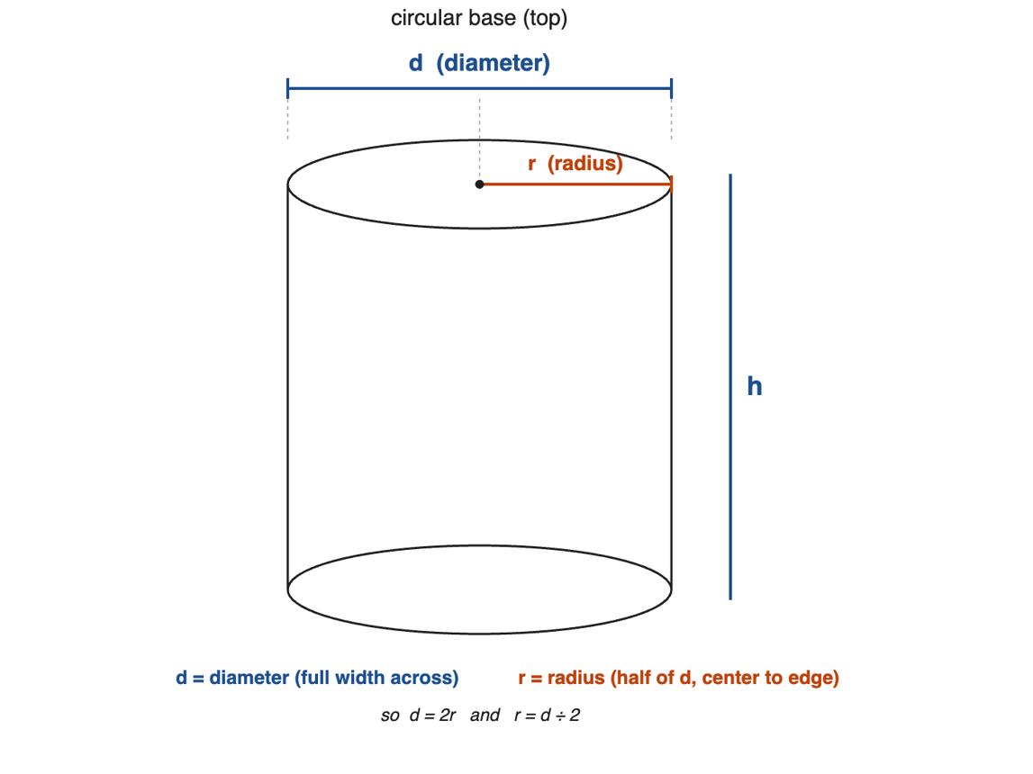
The diameter relates to these geometric components:
- Circular base: the solid circular face at the top or bottom of the cylinder.
- Center of the base: the central point of the circular face.
- Radius ($r$): distance from the center to the outer circular boundary.
- Diameter ($D$): distance across the entire circular base through the center.
- Height ($h$): perpendicular distance between the two base planes.
- Axis: the line joining the centers of the two bases.
For a right circular cylinder, the top and bottom bases are congruent, so both have the same diameter.
$$D_{\text{top}}=D_{\text{bottom}}=D$$

Mathematical Formulas

Diameter from Radius
# Source: AI Source: Provided by: [Data Path: Persons Table -> ID Column: 1, Name_En Column: Motasem Essam] -> From: [ChatGPT] on [7/25/2026]
$$\boxed{D=2r}$$

Radius from Diameter
# Source: AI Source: Provided by: [Data Path: Persons Table -> ID Column: 1, Name_En Column: Motasem Essam] -> From: [ChatGPT] on [7/25/2026]
$$\boxed{r=\frac{D}{2}}$$
4.3. Diameter from Base Circumference
The circumference of the circular base is:
$$C=2πr=πD$$
Therefore:
$$\boxed{D=\frac{C}{π}}$$

Base Area from Diameter
# Source: AI Source: Provided by: [Data Path: Persons Table -> ID Column: 1, Name_En Column: Motasem Essam] -> From: [ChatGPT] on [7/25/2026]
The area of the circular base is:
$$A=πr^{2}$$
Substituting $r=D/2$:
$$\boxed{A=\frac{πD^{2}}{4}}$$

Volume of a Solid Cylinder
# Source: AI Source: Provided by: [Data Path: Persons Table -> ID Column: 1, Name_En Column: Motasem Essam] -> From: [ChatGPT] on [7/25/2026]
The volume is the base area multiplied by the height:
$$V=πr^{2}h$$
Expressed using the diameter:
$$\boxed{V=\frac{πD^{2}h}{4}}$$

Curved Surface Area
# Source: AI Source: Provided by: [Data Path: Persons Table -> ID Column: 1, Name_En Column: Motasem Essam] -> From: [ChatGPT] on [7/25/2026]
For a right circular cylinder:
$$S_{L}=2πrh$$
Using the diameter:
$$\boxed{S_{L}=πDh}$$

Total Surface Area
# Source: AI Source: Provided by: [Data Path: Persons Table -> ID Column: 1, Name_En Column: Motasem Essam] -> From: [ChatGPT] on [7/25/2026]
For a closed right circular cylinder, including both circular bases:
$$S_{T}=2πr^{2}+2πrh$$
Equivalently:
$$\boxed{S_{T}=\frac{πD^{2}}{2}+πDh}$$

Worked Examples
# Source: AI Source: Provided by: [Data Path: Persons Table -> ID Column: 1, Name_En Column: Motasem Essam] -> From: [ChatGPT] on [7/25/2026]
Example 1: Finding the diameter from the radius
Given: Base radius $r=5\text{ cm}$.
Solution:
$$D=2r=2\left(5\right)$$
Answer: $\boxed{D=10\text{ cm}}$
Example 2: Finding the radius from the diameter
Given: Base diameter $D=24\text{ mm}$.
Solution:
$$r=\frac{D}{2}=\frac{24}{2}$$
Answer: $\boxed{r=12\text{ mm}}$
Example 3: Finding the diameter from circumference
Given: Base circumference $C=16π\text{ cm}$.
Solution:
$$D=\frac{C}{π}=\frac{16π}{π}$$
Answer: $\boxed{D=16\text{ cm}}$
Example 4: Finding volume from diameter
Given:
- Diameter: $D=6\text{ cm}$
- Height: $h=10\text{ cm}$
Solution:
$$V=\frac{πD^{2}h}{4}$$
$$V=\frac{π{\left(6\right)}^{2}\left(10\right)}{4}$$
Answer: $\boxed{V=90π{\text{ cm}}^{3}}$, approximately $282.74{\text{ cm}}^{3}$.

Key Characteristics
# Source: AI Source: Provided by: [Data Path: Persons Table -> ID Column: 1, Name_En Column: Motasem Essam] -> From: [ChatGPT] on [7/25/2026]
- The diameter is a linear measurement.
- It passes through the center of the circular base.
- It is twice the base radius.
- A solid cylinder has no inner diameter because it has no hollow opening.
- For a cylinder with congruent circular bases, the top and bottom diameters are equal.
- The base area depends on the square of the diameter.
- The cylinder's volume depends on the square of the diameter and linearly on its height.

Comparison with Related Measurements
# Source: AI Source: Provided by: [Data Path: Persons Table -> ID Column: 1, Name_En Column: Motasem Essam] -> From: [ChatGPT] on [7/25/2026]
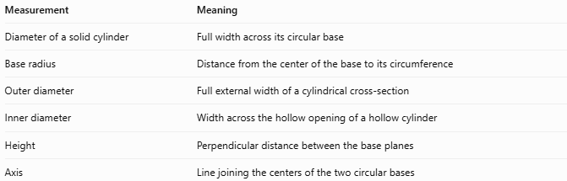
Measurement | Meaning
Diameter of a solid cylinder | Full width across its circular base
Base radius | Distance from the center of the base to its circumference
Outer diameter | Full external width of a cylindrical cross-section
Inner diameter | Width across the hollow opening of a hollow cylinder
Height | Perpendicular distance between the base planes
Axis | Line joining the centers of the two circular bases
Important distinction: For a solid right circular cylinder, the base diameter and external diameter are the same. The term inner diameter applies to a hollow cylinder, not an ordinary solid cylinder.

Applications
# Source: AI Source: Provided by: [Data Path: Persons Table -> ID Column: 1, Name_En Column: Motasem Essam] -> From: [ChatGPT] on [7/25/2026]
- Manufacturing: specifies the diameter of solid rods and cylindrical components.
- Construction: measures cylindrical concrete columns and supports.
- Mechanical engineering: defines the dimensions of solid shafts and pins.
- Geometry: calculates base circumference, base area, volume, and surface area.
- Material estimation: helps determine how much material is needed for a cylindrical object.

Key Points
# Source: AI Source: Provided by: [Data Path: Persons Table -> ID Column: 1, Name_En Column: Motasem Essam] -> From: [ChatGPT] on [7/25/2026]
- Symbol: $D$ or $d$
- Diameter: $D=2r$
- Radius: $r=D/2$
- Base area: $A=πD^{2}/4$
- Volume: $V=πD^{2}h/4$
- Curved surface area: $S_{L}=πDh$, for a right circular cylinder.

Conclusion
# Source: AI Source: Provided by: [Data Path: Persons Table -> ID Column: 1, Name_En Column: Motasem Essam] -> From: [ChatGPT] on [7/25/2026]
The diameter of a solid cylinder is the full distance across its circular base through the center. It is twice the radius and is one of the main measurements used to determine the cylinder's base area, volume, and surface area.

